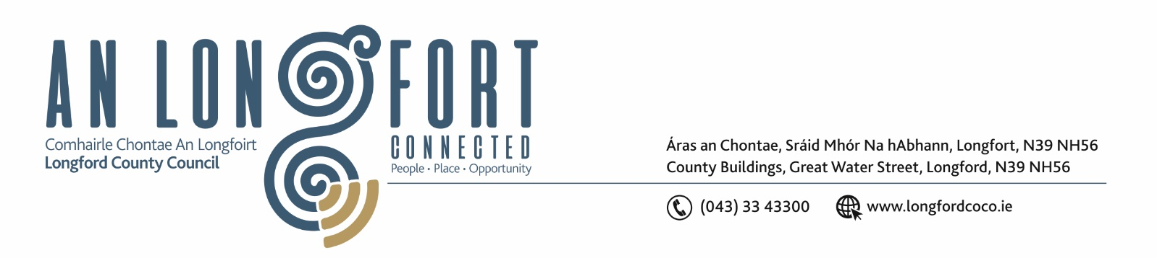
26th February 2019.

Please note - meeting time changed to 4.00 p.m. due to Garda Divisional Youth Achievement Awards Ceremony at 6.00 p.m.

To: Each Member of the Joint Policing Committee.

Re: Meeting of the Joint Policing Committee

Dear Member,

I wish to inform you that the next meeting of the Joint Policing Committee will take place in the Council Chamber, Aras an Chontae, Great Water Street, Longford, on Monday, 4th March 2019 at 4.00 p.m.

The Presentation of the Garda Divisional Youth Achievement Awards will take place at 6.00 p.m.

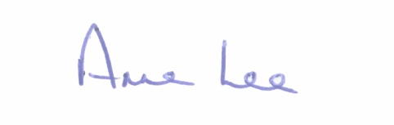
Yours sincerely,

___________________
Anne Lee,
Administrative Officer.
AGENDA

1. Confirmation of Minutes of Joint Policing Committee meeting held on the
3rd December 2018 - enclosed.

2. Matters arising.

3. Garda Report.

4. Local Authority Report.

5. Consideration of Longford JPC 2018 Annual Report – enclosed.

6. Road Traffic (Amendment) Act 2018 - referred from January 2019 Meeting of Longford County Council.

7. Update on Longford Joint Action Plan.

8. Date of next meeting .

